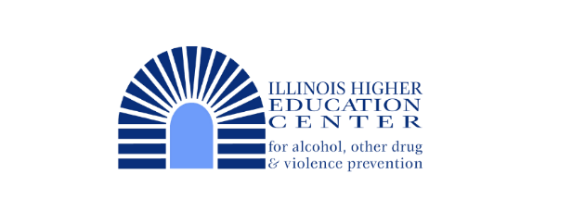

FY2026 Survey Administration
Survey distribution & collection will happen in the late winter/early spring of 2026; institutional recruitment will close by December 12, 2025.
Illinois Assessment of College Substance Use Behaviors (IACSUB) Survey
(Illinois Institutions Only)
Purpose
This survey is to determine the current incidence and prevalence of alcohol and other drug use on Illinois 2 and 4-year college campuses. Furthermore, students’ perception of others’ use; perceptions of risk related to use; beliefs regarding use; negative consequences associated with use; experiences of secondhand effects of others’ use; experiences of physical and sexual violence; and the relationship of alcohol and other drug use to campus climate issues will, also, be examined.
Background
The first administration of the Illinois Assessment of College Substance Use Behaviors Survey was completed in 2024. Data was collected in-house, cleaned, and sent to participating schools in 2025. Through review of the staff, the survey design has gone under revision for improved user outcomes and alignment with the grant deliverables.
This new survey method was adapted from our Missouri colleagues, Missouri Partners in Prevention. Their original document, the Missouri Assessment of College Health Behaviors, or MACHB, was shared with our office to modify and create our new survey tool. The new method of administration keeps all the work in-house, allowing for more collaborative work and data reporting for the state.
Previously, the Core Alcohol and Drug Survey was administered on a statewide basis in the spring semesters of 2006, 2010, 2012, 2014, 2016, 2018, 2020, and 2022. During our 2012 administration, approximately 12,600 students at 23 Illinois institutions of higher education (16 four-year institutions and 7 two-year institutions) participated in the administration. Moving forward, we are no longer working with CORE or utilizing the CORE survey. In place of the Core, we are administering our newly developed IACSUB survey.

Benefits
- No cost to your institution
- Survey distribution, collection & data processing are done in-house
- Survey results will not be shared with other institutions, only you or delegated people will receive a copy of your institution's results
- Administration will be done in early spring pending approval, will run for approximately 3 weeks during your indicated timeframe.
  - Suggested timeframes will vary depending on unique academic calendars & break schedules
- Survey will be distributed using the EIU Qualtrics platform through email notifications and reminders.
  - Surveys will take about 20 minutes to complete, focusing on substance use, harm reduction efforts, mental health, retention and similar topics.
- Conducting a needs assessment will help target prevention resources and make programming efforts justifiable, fundable and measurable.
- Data can also assist in defining the nature and extent of the existing campus alcohol and other drug problems, and in identifying high-risk groups within the higher education population.
General Procedures:
- Application/Interest forms completed, IRB documentation submitted (as needed)
- Consultation with IHEC staff regarding details of institutional needs and goals
- Identify timeframe for distribution
- Create email template with preferred formatting and information related to institutional distribution
- IHEC staff set up distribution dates, email formatting, and reminders
- Random samples are collected from participating institutions and uploading into Qualtrics for email distribution
- Data is collected during the scheduled timeframe
- Executive Summary and raw data files sent to institution in the following summer/fall months
  - Data can be used for Biennial Review processes & consultation visits to assess prevention capacity and needs
Participation Steps:
- Register your Institution through our provided Machform on our website.
- A letter must be on the facility’s letterhead stationery or e-mail, and should contain the following:
  - Agreement for the study to be conducted at the site (IRB paperwork as needed)
  - Identification of someone at the site who will provide information about appropriateness of the study for its population.
    - This person will serve as the main point of contact for survey administration, data collection & results
  - Assurance of adequate capabilities to perform the research as approved by the IRB; and if applicable:
    - Assurance that facility personnel involved in data collection have appropriate expertise and will follow IRB approved procedures.
- Send us a random student sample (names and emails) from your registrar's office.
  - We recommend a random sample of 10% of the student population on your campus
    - Excel file preferred
- Provide us with the tentative timeframe you would like to run the study (must be completed by April 30, 2026.
  - We recommend a three-week timeframe to administer the survey. Reminder emails can be sent weekly for improved response rates.
- Provide us with a draft email to include when survey distribution is provided on your behalf.
  - You must include contact person for the survey, any giveaway information for your campus, and any other survey specific notes.
    - Note: We are not responsible for any giveaway proceedings. Institutions that choose to do so can be provided with emails from students that opted in.

Example of “Intent to Participate” Letter
